Lower Merion Conservancy StreamWatch

Background
This water quality monitoring effort is part of a larger initiative funded by the William Penn Foundation called the Delaware River Watershed Initiative, started in 2014 with the goal of improving water quality in the Delaware River Watershed as a whole. Five watersheds in the suburban Philadelphia region are part of this initiative: the Cobbs, Pennypack, Poquessing, Tookany-Tacony-Frankford, and Wissahickon Watersheds. Each of these watersheds has a group of volunteers monitoring the water quality of their creeks. Citizen scientists like you will collect valuable data on stream health, come away with a better understanding of their watershed, and become more empowered to promote actions that improve watershed health.

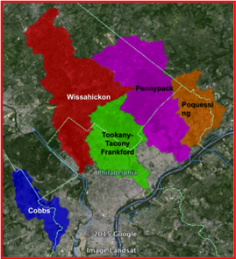
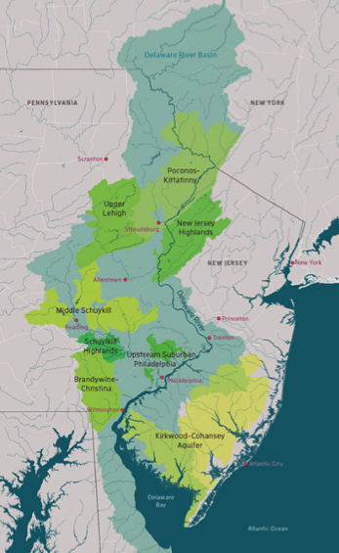
The Delaware River Watershed Initiative – Upstream Suburban Philadelphia Cluster

About the Program

The Lower Merion Conservancy’s StreamWatch Program expands our capacity to monitor the creek by enabling trained volunteers to gather data on new areas of the watershed that have not been studied in the past. Your help in collecting this vital information will help address issues in the watershed and understand the threats to the system better than ever.

Goals and Purpose:
Your participation in the StreamWatch Program aims to:
- Promote the long-term protection and restoration of local streams.
- Improve the understanding of the natural and cultural importance of a local stream as well as major threats to the system.
- Develop a network of volunteers that will provide early detection of environmental concerns for the watershed and help determine on areas to focus on.
- Expand the capacity of existing monitoring efforts in increased locations and frequency of monitoring.

Program Overview

Monthly commitment:
Stream Keepers are asked to commit about two hours per month for monitoring an assigned stream section and submitting your data to the Lower Merion Conservancy (see page 11 for information on where to submit data). Your monitoring should be conducted around the same time each month, if possible.

Training:
The Lower Merion Conservancy staff will provide all citizen science volunteers with an introductory training, which will familiarize you with everything you need to know to begin monitoring your creek section, including background on watershed health indicators and monitoring protocols. Optional additional trainings will be provided throughout your tenure in the program by the Lower Merion Conservancy and our partners in the Delaware River Watershed Initiative.

Creek sections:
The Lower Merion Conservancy has established monitoring sites in key locations where volunteers will collect data on water quality and creek health. You will be assigned a site for your monthly monitoring. A Stream Keeper can also have the option of setting up a new monitoring site, so long as it is coordinated strategically with your volunteer coordinator.

Guidelines for Monitoring
Here is a list of several things that you may want in the field with you:
- Notebook and data sheets (incident report, photo log)
- Copy of your stream section map
- Camera
- Pencil/Pen (water insoluble, e.g. ball point pen)
- Sturdy walking shoes or waders (optional)
- Walking stick
- Drinking water
- Insect/tick repellent
- Sunscreen
- Charged cell phone
- Medication (if appropriate)
- List of contacts
- Backpack to carry supplies

Safety tips:
- We want you to have a fun and be safe when you are at the stream. Here are several safety tips for monitoring:
- Check the weather before going in the field.
- Be aware of your parking location. Be mindful of where you are going to prevent getting lost.
- Carry a cell phone and place in waterproof bag.
- Put your wallet and keys in a safe place.
- Carry a first aid kit and have any medication when you are in the field.
- Dress appropriately for the conditions.
  - Wear protective clothing to prevent ticks. Educate yourself on Lyme disease and conduct tick checks at the conclusion of fieldwork.
  - Wear appropriate layers in the winter when temperatures are cooler.
- Be cautious of stream banks. They are often slippery, uneven, and may and have harmful plants (poison ivy, stinging nettle, multiflora rose, etc.). Do not scale steep slopes.
- Avoid fast flowing or deep water.
- Be able to identify and avoid hazardous plants (e.g., poison ivy, stinging nettle, multi-flora rose and Japanese hops).
- Contact 911 for help in an emergency.

Monitoring:
Stream Keepers will monitor using the Citizen Science field sheet, which can be found in Appendix A. The data will be used to identify problem areas in the creek, areas in need of more investigation, and areas in need of immediate attention. We encourage you to fill out the sheets with as much detail as possible each time you are at the stream. This will help you to recall more information when submitting your data.
When to monitor:
Please monitor around the same time each month, if possible. Monitoring during or after storms can be valuable but if you have any concern about the weather do not feel obliged to monitor.

Filling out your monitoring form

Section:
The name of the section of the creek that you are monitoring, as assigned

Water body:
This will be the name of the creek you are monitoring

Date:
The date monitoring was conducted (around the same time each month).

Monitors:
The first and last name of the citizen scientist(s) monitoring the site that day

Time started and ended:
The time you started and ended the monitoring session (should be around the same time of day each month for consistent observations).

Days since last rainfall:
The amount of time that has passed since the last rainfall, typically in number of days, or hours if it has been less than one day.
You can find rainfall data here: https://www.wunderground.com/history

Approximate rainfall:
This is the amount of rainfall during previous rain events. This information will help us determine if the conditions that you are observing are an artifact of a recent storm event. If it has been more than three days, simply record “over three days” and you do not need to include amount of rainfall.
You can find rainfall data here: https://www.wunderground.com/history

Current weather:
Choose one category that best describes the weather you observe during monitoring. (Ex. Cloudy, Clear, etc.)

Water Clarity:
Decreased water clarity can indicate sediment or other suspended particles are entering into the stream from runoff or erosion, or being stirred up from the streambed in a storm event, which is a frequent problem in our watersheds. The cloudiness of the water is also called “turbidity”.
- Clear – No obvious turbidity (cloudiness).
- Slightly Cloudy – Water is cloudy, but the bottom of the streambed is still visible.
- Cloudy – The streambed can only be seen in shallow areas, but not in deeper sections.
- Opaque/Chocolate Milk – The streambed cannot be seen through the water, even in shallow areas.
Tip: Not sure how cloudy the water really is? If possible, submerge your hand below the surface of the water. If you can still see your hand in detail, and the colors are not murky, the water is pretty clear! If the details are muted and the color of your hand changes under water, there are likely suspended sediments in the water. This is a good way to easily judge clarity of the water in your stream.

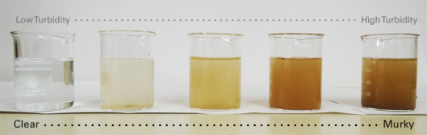

Surface Coating:
Surface coatings can be from natural processes or may indicate a problem in the stream.
- None/clear – Normal with no surface coating
- Bubbles – Naturally occurring bubbles are from the biological process of breaking down material in a stream. These bubbles become brown overtime, are common after rainfall, move relatively evenly downstream, and build up in slow areas. Bubbles that indicate a problem will commonly come from one distinct location and the individual bubbles may have an iridescent shine to them. The photograph below shows an instance of a detergent creating non-naturally occurring bubbles in the creek.
- Scum – Scum can also be part of a natural process, particularly in areas with little or no flow and in the late summer.
- Oily – Like bubbles, oily sheens are commonly part of a natural process, particularly in slower waters. Take a stick and move it through the sheen. If it breaks up into flakes and stays apart, the sheen is part of a natural process of bacteria breaking down materials. If the sheen will not break up, breaks into smooth circles, or immediately reforms into the same sheen it could be an indication of a spill.

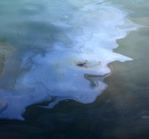
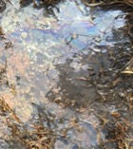
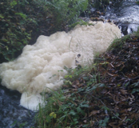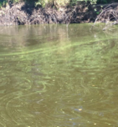
BUBBLES (unnatural) SCUM BACTERIAL SHEEN OIL SHEEN

Odor:
The odor of the stream can indicate natural ecological conditions or a problem in the stream.
- Normal – No odor or a normal odor.
- Sewage – Sewage may indicate treated water releases from sewage treatment plants.
- Rotten Eggs – May indicate that the bottom waters and sediments have no oxygen reaching them.
- Chemical – An example of a chemical smell you may encounter is chlorine from swimming pools.
- Petroleum or a gas smell – May indicate that there has been a spill nearby.
- Other – If you smell anything else that does not fit in these categories, please describe the smell as best you can.

Streambed color
The streambed color can indicate biological or chemical functions at the site. Pick the color that best describes the site.
- Orange/red – Orange to red deposits could be cause by acid drainage (alert volunteer coordinator) or because of natural iron bacteria in the water (this is normal and not harmful).
- Yellow – Indication of sulfur entering the stream or stream bed, possible industrial waste or coal-using operation
- Black – If the bottom of the stream contains a lot of bedrock that is not covered by sediment and algae, the streambed can look black or grey.
- Brown – Sedimentation deposition caused by erosion (muddy or cloudy).
- Green – If the stream is excessively green, this could be an indication of nutrients being released into stream, feeding algae, possible fertilizer or manure run-off areas.
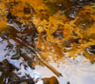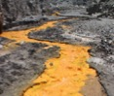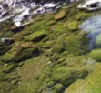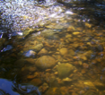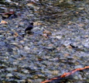
Orange Yellow Green Brown Black

Percent canopy cover
Canopy cover comes from the growth of streamside trees. Trees are important for the survival of aquatic organisms because they shade the water surface, regulating the temperature of the stream, slowing the growth of algae, stabilizing the streambanks, and providing habitat. Estimate the percentage of the stream covered by the shadows of trees and shrubs when you are at your site (this is easiest on a sunny day). On overcast days it may be more difficult to estimate the amount of canopy cover by shade cast on the water. Instead, look up at the tree canopy and try to estimate the density of trees by how much sky you can see through the treetops and branches. It is best to be consistent about what time of day you visit your site so you are using the same baseline each time you monitor.

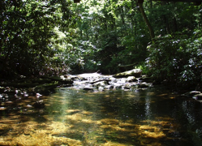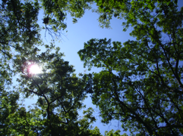

Algae cover
Some algae growth is important to maintaining a stable ecosystem. Overabundance of algae, due to excess nutrients from stormwater runoff or too much sunlight, can reduce the concentration of dissolved oxygen. As dissolved oxygen levels decrease, fewer aquatic animals can survive. Please select a category below that best approximates the algae cover at your site.
- Rare – Covering 0-30% of the streambed
- Moderate – Covering 30-70% of the streambed
- Abundant – Covering 70-100% of the streambed
If you have difficulty assessing the algae cover when looking at the streambed, pick up and inspect a few submerged rocks to observe the algae more closely. Be sure that you are looking at the average amount of algae throughout your entire stream section, not just what’s right in front of you.

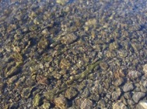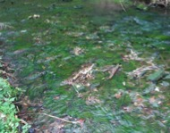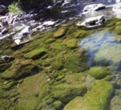

Flow
Choose the category defined below that best summarizes the flow pattern of your site. Recent rainfall, or lack thereof, as well as physical changes on the streambed and stream banks can affect flow. Photographs from previous visits can be useful for comparison.
- Slow – Very little or no noticeable water movement.
- Moderate – Water is clearly moving. In areas where the water is deep and rocks are fully submerged the water surface is even and flat.
- Swift – Water is moving quickly. In areas where the water is deep and the rocks are fully submerged the water surface is uneven. Please note whether swift flow is due to an obstruction or a bottleneck in the streambed.
- Combination – An even combination of the above categories with no single category dominating the site.
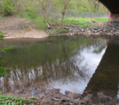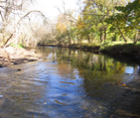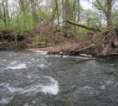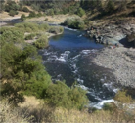
Slow Moderate Swift Combination

In-Stream Habitat (%Riffle/Run/Pool)
The type of in-stream habitat and flow has an impact on the type of macroinvertebrates and fish that can live there. We are considering three different types of in-stream habitat in this section: riffles, runs, and pools.
- Riffle – swift/fast flow, water breaks over rocks, “rapids”
- Run – swift flow without water breaking (no white caps), deeper water than riffles
- Pool – stagnant water with little flow
When looking at your creek section, note the approximate proportion each one of these in-stream habitats account for. It will help to look back at previous site photos to reference where these habitats are and how their proportions may have changed. Record these proportions as a percentage of the total creek section being considered. These three percentages should add up to 100% every time.
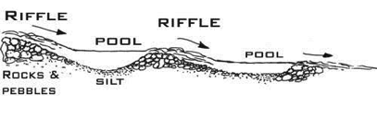

Leaf Packs
Leaves, falling in or near the stream, leach out vital organic molecules creating a “watershed tea” that flows downstream, providing nourishment to the stream ecosystem. On the leaves that accumulate in the water, there are typically diverse assemblages of microbes (fungi and bacteria) and macroinvertebrates (insect larvae, crustaceans, etc.) which “process” leaves and facilitate the flow of energy through the ecosystem. Macroinvertebrates are often referred to as “canaries of the stream” because they function as living barometers that indicate changes in water quality. Leaf packs are important for some aquatic insects, known as shredders. Shedders are absent from many of our local creeks, and could be the result of a missing food source. Please indicate the on your field sheet the estimated number of leaves that are accumulated in packs (e.g. built up behind a rock or in a pile at the bottom of a pool), and not leaves moving on the water surface.
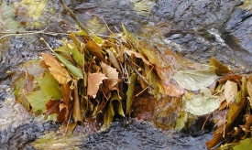

Aquatic vegetation
Aquatic vegetation refers to vegetation growing in the streambed. The Upstream Suburban Philadelphia Cluster watersheds do not have much aquatic vegetation. We are therefore interested in noting what aquatic vegetation is found throughout the watersheds. Please describe any aquatic vegetation you observe and take a photo.
- None – No vegetation growing in the water.
- Floating – Vegetation that floats on the stream surface and is not attached to the streambed. Example: Duckweed.
- Rooted submerged – Vegetation that is attached to the streambed with a root system and is entirely submerged underwater.
- Rooted floating – Vegetation that is attached to the streambed with a root system and floats on the water surface. Example: Lily pad.
- Rooted emergent – Vegetation that is attached to the streambed with a root system and emerges through the surface of the stream. Example: Cattail.
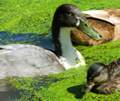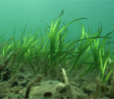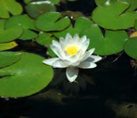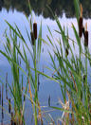
Floating Rooted submerged Rooted floating Rooted emergent

Erosion
Sediment is a known impairment in Upstream Suburban Philadelphia watersheds and is detrimental to aquatic life. Look back to the prior month’s photograph and indicate any changes in the erosion patterns since your last visit. Please describe any of the categories that you circle in detail.
- Continued bank erosion – The continuation of an already established erosion pattern. This includes a decreasing bank being further eroded.
- New bank erosion – A new or distinct change in the pattern of erosion.
  - Example: A tree fell and the altered water flow created a new area of erosion.
  - Example: An area that had continued bank erosion has significantly accelerated.
- Increased or decreased sediment deposition – During a storm event a lot of sediment is carried downstream and eventually settles on the streambed, sometimes creating an island or point bar.
  - Example: A new rocky area has built up on the stream bottom that was absent the prior month.
- No change – Between your last monitoring visit and now, there has been no noticeable change in erosion or sedimentation patterns at your site.

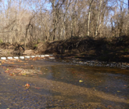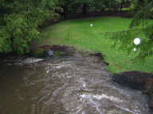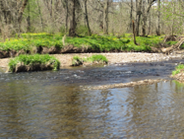
Continued erosion New bank erosion Sediment/deposition change

Riparian vegetation
A riparian corridor is the land that borders a stream. Ideally, a riparian corridor is vegetated with native trees, shrubs, and/or other plants and extends from the stream bank at least 50 feet into the land. Stable riparian vegetation can reduce impacts from stormwater and provide habitat for wildlife.
For initial visits, please describe the riparian vegetation at your site. During subsequent visits, compare your previous photos to the current conditions and identify any changes.
Please select any of the categories defined below that apply to your site:
- Increased or decreased abundance – Change in the amount of vegetation along the stream corridor. This change can be seasonal.
- Change in types – A change in the type of vegetation since the last visit. An example is an invasive plant expanding its growing area.
- Fallen trees – Any trees that have fallen into the streambed or onto the riparian corridor. Be sure to photograph the tree and observe the types of plants that start to grow in the tree’s place.
- No Change – The riparian vegetation looks the same as it did during your previous visit.

Animal Observations
The animals that you encounter while monitoring are
important indicators for water and habitat quality. Whenever you monitor, keep
an eye out for all kinds of animals and record what you find.

- If you know the specific species, note that. If you can’t identify the animal, attempt to describe it.
- Whenever possible, take photographs of the animals you find. Label those photographs using the format designated in the “Site Photographs” section of this manual – noting what you think you have found in the photo description portion.

Site photograph
Three or four site photographs need to be taken each time the site is visited using the same angle, zoom, and facing the same direction. These three or four photographs should all be taken from the same location with one photo looking upstream from that location, one looking downstream, and one or two looking down at the nearby stream banks. Additional photos taken in different locations are welcome. We will provide you a few example photos of how these should be taken. These photos should be submitted to the Lower Merion Conservancy using this titling format:

SiteID-ddMONTHyyyy-full name-photo description

*If you have difficulty naming the file in this format, please try to name it with something that indicates the site and date.

Submitting data:
Email the datasheet below as well as any pictures to Tom@lmconservancy.org.
APPENDIX A – FIELD SHEET

Citizen Science Field Sheet
Section: |  | Date: |  |  |  |  | Time Started:
Water body: |  |  | Monitors: |  |  |  | Time Ended:
Days since last rainfall: |  |  |  |  | Approximate rainfall:
Current weather: | Clear |  |  | Partly cloudy | Overcast | Rain (light, steady, heavy) |  | Snow

Monitoring Site Data
Site photo file name (Section-ddMONTHyyyy-full name):
Circle one choice
Water clarity: |  |  | Clear |  |  |  |  |  |  |  |  |  |  |  |  | Slightly cloudy |  |  |  |  |  |  |  |  |  | Cloudy |  |  |  |  |  |  |  |  |  | Opaque/chocolate milk
Surface coating: |  |  | None/clear |  |  |  |  |  |  |  |  | Bubbles |  |  |  |  |  | Scum |  |  | Natural Precipitate |  |  |  |  |  |  |  |  |  |  |  |  | Oil - Synthetic |  |  |  |  |  |  | Other:
Odor: | Normal |  |  |  |  |  |  |  | Sewage |  |  |  |  |  |  |  | Rotten Eggs |  |  |  |  |  |  | Chemical |  |  |  |  |  |  |  |  |  | Petroleum |  |  |  |  | Other:
Stream bed color: |  |  |  | Orange/red |  |  |  |  |  |  |  |  |  |  |  |  | Yellow |  |  |  |  |  |  |  | Black |  |  |  |  |  |  |  | Brown |  |  |  |  |  |  |  |  | Green
% Canopy Cover: |  |  |  |  | Less than 30% |  |  |  |  |  |  |  |  |  |  |  | 30-50% |  |  |  |  |  |  |  |  |  |  |  |  | 50-80% |  |  |  |  |  |  |  |  |  | Greater than 80%
Algae cover: |  |  |  |  |  |  |  |  |  | Rare (0-30%) |  |  |  |  |  |  |  |  |  |  |  | Moderate (30-70%) |  |  |  |  |  |  |  |  |  |  |  |  |  |  | Abundant (70-100%)
Flow: |  |  |  |  | Slow |  |  |  |  |  |  |  |  |  |  |  | Moderate |  |  |  |  |  |  |  |  |  |  |  |  | Swift |  |  |  |  |  |  |  |  |  | Combination
Leaf packs: |  |  |  |  | None |  |  |  |  |  |  |  |  |  | Individual leaves (single floating leaves) |  |  |  |  |  |  |  |  |  |  |  | Small leaf packs  (5-20 leaves) |  |  |  |  |  |  |  |  |  |  | Large leaf clumps  (>20 leaves)
Circle and describe all that apply
In-stream features |  |  |  |  |  |  | Riffle |  |  |  |  |  |  |  |  |  |  |  | Run |  |  |  |  |  |  |  |  |  |  |  |  |  |  |  | Pool
Aquatic vegetation: |  |  |  |  |  |  | None |  |  |  |  |  | Floating |  |  |  |  |  |  | Rooted submerged |  |  |  |  |  |  |  |  |  |  | Rooted floating |  |  |  |  |  |  |  |  |  |  | Rooted emergent
Erosion: |  | No change or  Continued bank erosion |  |  |  |  |  |  |  |  |  |  |  |  |  |  | New bank erosion |  |  |  |  |  |  |  |  |  |  |  | Increased sediment deposition/islands |  |  |  |  |  |  |  |  |  | Decreased sediment deposition or islands
Riparian vegetation: |  |  |  |  |  | No change |  |  |  |  |  |  |  | Decreased abundance |  |  |  |  |  |  |  |  |  | Increased abundance |  |  |  |  |  |  |  |  |  |  | Change in types |  |  |  |  |  |  |  | Fallen trees
Animal observations: |  |  |  |  |  |  |  | None |  |  | Fish (alive) |  |  |  |  |  | Fish (dead) |  |  |  |  |  | Birds |  |  |  |  | Insects |  |  |  | Mammals |  |  |  |  |  | Reptiles Amphibians
Describe:
Additional notes:

